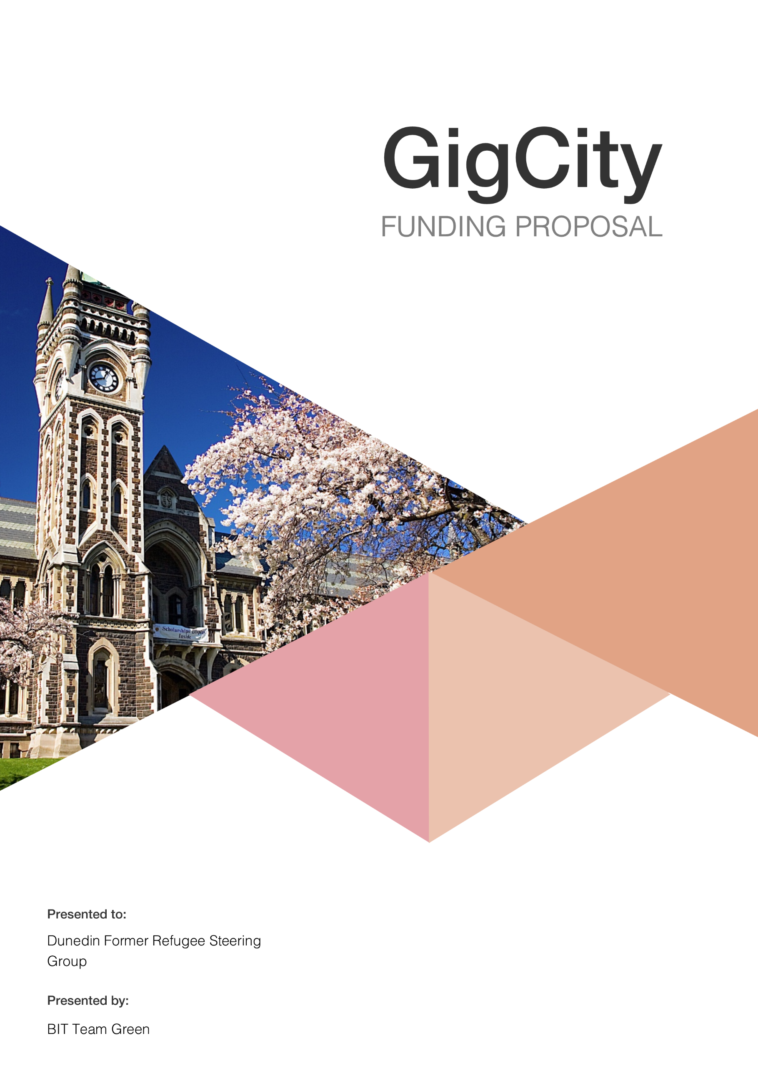

# Executive Summary

The Dunedin Former Refugee Steering Group is a non-profit organization actively looking to assist former refugees in their integration and settling into their new home in Dunedin, New Zealand.

At present, former refugees don't have a unique online presence, which puts them at disadvantage regarding keeping in contact with communities and support services.

A well-designed website that is user friendly and easily accessible, and a social media hub would assist all parties involved and fix the current problems they are facing.

BIT Team Green has created this funding proposal, based on the information and specifications received by the Dunedin Former Refugee Steering Group, to provide a solution to their problem. Doing so will give them the information they need to apply for GigCity community funding.

BIT Team Green is proposing an IT solution to address the needs of the group. The proposed website and social media pages will include the following features:

* An accessible and easy to use website
* Former Refugee Page including:
  + All information they may need e.g. maps, Dunedin FAQ
  + An opportunity to communicate on a former refugee forum
  + Page translations offering ease of access for all nationalities
* Section of the website for organizations, including:
  + A simple blog of actions organizations are taking, with comments available for discussion
  + Resources (Building plans, statistics)
* A page open to the Dunedin community, including:
  + Contact information for organizations
  + Details regarding volunteer work
  + Information about the former refugees and where they’ve come from.

After consulting several website development companies, it seems that the project will take 2-3 weeks to complete, depending on the company and scope of the website.

Table of Contents

Executive Summary 2

Introduction 4

Project Objectives 4

Technology Solutions 4

Website Design 5

Social Media 6

Visual Aspect 6

Navigation 6

Information feeds 6

Estimates and Quotes 7

Conclusion 10

Recommendations 11

References 12

APPENDICES 13

Appendix A 13

# Introduction

Recently the city of Dunedin, New Zealand was selected to be the new home for refugees from across the world. The process of bringing refugees to Dunedin and settling them in our community is well underway, with many refugees already housed in the city, and many more to come.

The Dunedin Former Refugee Steering Group is a non-profit organization put in place to ensure all needs for the former refugees are met, and that they feel welcome and supported within our city.

The group is seeking funding from the GigCity Community Fund, which is set up to aid business and organizations in establishing new technological projects within Dunedin. The full amount of $20,000 would give the group the means to set up a website focused on helping former refugees with their integration into New Zealand life.

# Project Objectives

Our objectives are:

* Give the former refugees living in Dunedin the opportunity to have their very own unique identity via their own interactive website.
* Use the website to help them transition to settling into Dunedin.
* To educate the wider community in Dunedin about the former refugees.
* Encourage more interaction between organizations that are associated to the Dunedin Former Refugee Steering Group

# Technology Solutions

Choosing the right technology solution for any problem isn’t an easy decision. Here at Otago Polytechnic, our team came up with the idea of creating a unique and interactive website that represents former refugees living in Dunedin. This new and exciting website solution will cater to their needs and quality of living not just in Dunedin, but New Zealand in general.

Our proposed website solution would also allow associated organisations (The Red Cross, Housing NZ, and Dunedin City Council) to interact with each other, share resources and provide a more efficient platform to support the refugees. Another initiative would be to include the wider Dunedin community as well as the rest of the world to access the website to get a better understanding of the Dunedin Refugee Steering Group’s identity and purpose in Dunedin.

## Website Design

**Overall aspects**

The website will need the ability to provide access to various aspects and sections such as:

* An intuitive set of editing tools.
* Ability to expand the functionality of the website over time.
* Ability to add/update layout/design as needed in future but suggest a uniform layout is used initially.
* Plugins/extensions to connect to information feeds in and out of the website.
* Gather information statically to see what is being viewed and how often, using Google Analytics.
* Cross-browser compatibility across multiple devices.
* Platform that is updated as technology evolves to stay modern.
* Flexible design tools including simple animation.
* Assigning different groups to login to the website for different features

The World Vision’s website is an excellent website and a good example regarding design for the proposed website. It provides impact but keeps upbeat with the imagery and colors used.

Our initial idea is to have a main site which has an introduction into who the Dunedin Steering Group are and their purpose. From the main page, there would be options to explore separate sections which include:

**Former Refugees**

This section of the website opens to another page with material relevant to the refugees, such as local and homeland/foreign news, local links, and important contact information for emergencies (Hospital, Doctors, Police, Fire). We suggest having a separate interactive forum for the new migrants to communicate and have a place to socialize with each other (Facebook RSS feed to help could with this). All information they may need e.g. maps and Dunedin FAQ will be accessible, alongside translations offering ease of access for all nationalities.

**Organisations (Affiliated):**

This would include the Dunedin Refugee-Steering Group, The Red Cross, Dunedin City Council, Housing NZ and other organisations and charities. The section offers links, bios, and resources, that can be shared throughout the organizations. Having their own login section could benefit, offering personalized access to shared resources.

**Dunedin Community:**

The Dunedin Community section would enable the whole community to view and access news regarding what's going on in the community, show them how they can help the former refugees in any way, local news, events, and how to become a volunteer with sign up details to help where they can. Adding an interactive 360-degree view map1 over Dunedin showing landmarks and relevant sites would benefit not only the migrants but the wider community as well.

## Social Media

Having a social media presence would help advertise the organization better. A unique Facebook page and other social media pages that links to the site could be created, marketed and managed from a local Dunedin web and social media company called *Nudge Marketing.* They specialize in helping organizations have a presence on all social media platforms as well as website design.

## Visual Aspect

Visually it will be engaging based on imagery of the cause and the refugees. It would have a real impact on the audience and helps connect with real people.

This will require quality images from either image banks or professionally taken if not available. Strong H Tags for main titles and clear above average font size to balance the large rich imagery.

## Navigation

It would need to be clear and use obvious icons for main sections. Consider multi-language for those not fluent with the English language and feel connected to the website. Will need to consider possible RTL (Right to Left) languages if converted in website.

## Information feeds

Info feeds from external websites regarding news and local links. An RSS feed2 from Facebook can be added. A bulletin board type post showing need/available to provide services for transport could be added. Using Instant Messenger or tools of Social Media and groups to organize events, and travel etc. could be an option. There could be a registration for separate roles including volunteering.

## Permits and Consents

At this stage, there aren’t any permits or consents to complete the website. However, sites such as the Red Cross, Housing NZ and Dunedin City Council may have a friendly consent to link their sites to the project site. Basic terms and conditions would be a standard procedure for any website registering users on its database.

# Estimates and Quotes

We worked alongside two different website development companies and from the information provided to them relating to the proposal, here are their estimates and quotes:

**Website Design Hosting**

This company2 based in Christchurch thrives on excellence and continues to produce quality websites (see figure 1) eg. Coca-Cola, Novus Glass and Corporate Consumables just to name a few.

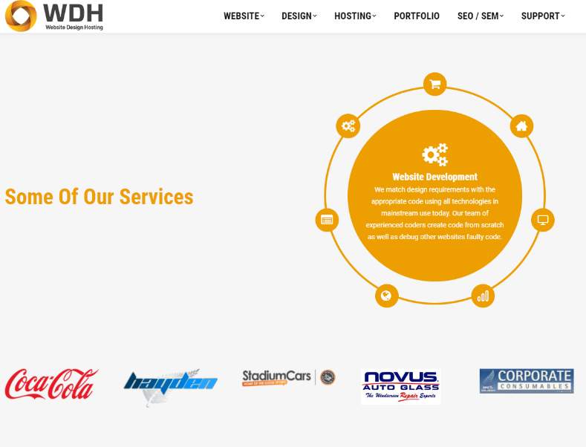

*Figure 1. Website Design Hosting Website.*

Until the Dunedin Refugee Steering Group have specific particulars and requirement of imagery, they cannot provide a final quote but this estimate is set to the higher end of what would be expected. Also, they based it off a similar design being the world vision website that is similar to our initial idea (just to get visual idea)

Website Build - **$6,500+gst** based on imagery, section structure and textual content provided. If we need to provide then cost will be in addition to this.

* Proof of Concept design once imagery and content defined.
* Based on using a CMS platform –WordPress (most used web platform used in the world.)
* Using and advanced theme as the base for design along with Visual Composer and Slide plugins.
* Installing/purchasing where needed plugins and configuring.
* Security plugins loaded/configured.

Hosting – based on disk space requirement – **$100+gst/month** providing 1GB of disk space.

* NZ Datacentre with daily/weekly/monthly backups.
* We can provide full email services as well.
* Includes SLA which covers 24/7 monitoring of server and techy support as we require form the Datacentre.

Domain name registration

* **$39.95+gst/year.**

Additional services

* Apply Monthly updates for WordPress platform and plugins as available **$10+gst/month**.
* 3rd party monitoring for any website interruptions. Alert by SMS, email and monitored every 1-5 minutes. **$20+gst/month**.
* SSL cert for added security of data transmission in forms etc. from (for standard SSL cert <http://www.websitedesignhosting.co.nz/ssl-certificates/> ) **$189+gst/year** including purchase, install and configure.

*Overall Total:* ***$9531.20 incl.gst*** *for build and first year maintenance and additional services. (Note: Until final details are approved price may vary)*

**Nudge Marketing**

Nudge is a local Dunedin based web and social media company (see figure 2) that’s keen to collaborate for this project.

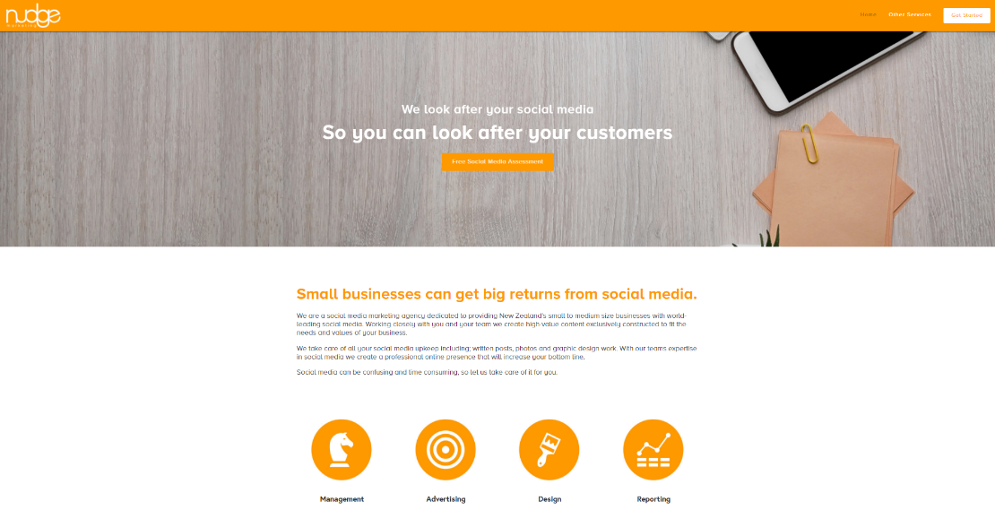

*Figure 2. Nudge Marketing Website*

Website Build – Complete multipage **$1500+gst**.

Note: additional features may incur fee.

Hosting **$16.99US p/m** (paid to Squarespace).

Social Media Management (Social Expert) shown in Appendix A.

**$600+gst/month**.

* Manage all social media duties including, written posts, photos and graphic design work.
* 7-9 posts Across Multiple Platforms.
* Graphic Design.
* Monthly one-on-one consultations.
* Fortnightly skype/phone call.
* Targeted Advertising Campaigns.
* Monthly Reporting.
* Event page Setup/Management.

*Overall Total:* ***$2415 incl.gst*** *for build and first year maintenance and additional services. (Note: Until final details are approved price may vary)*

## Timeline

**Website Design Hosting**

* Once the POC (Proof of Concept) has been signed off, for build time please allow 15 working days to complete.
* We currently have a 3-day lead time.
* An Account Manager will be assigned and will apply/manage any future task you may have.

**Nudge Marketing**

* Have an updated overview of the project with the client then the build can start straight away.
* A dedicated account manager will be assigned and will apply/manage any future task you may have.

## Next Milestone

Both WDH and Nudge Marketing require:

* Face to Face meeting.
* Defining sections of the website, imagery and textual content sourced.
* Defining functionality requirements as indicated above.
* POC.

# Conclusion

This information presented shows the technology solution chosen is more than capable of fulfilling the needs of The Dunedin Refugee Steering Group, affiliated organisations and benefiting the wider Dunedin community. It will be a first to have a unique website that represents these families that have settled here and future generations to come.

This project has the potential to grow even further to a national initiative involving all refugees arriving in NZ.

# Recommendations

Assuming all information is approved from GigCity4 and funding is approved, we confidently recommended that you:

1. Implement Website Design Hosting’s detailed website solution which will ensure a reliable website that will be of high quality.
2. Implement Nudge Marketing for social media management.
3. Setup a face-to-face meeting with WDH and Nudge Marketing to go over finer details e.g. imagery, functionality and other aspects to fine tune the POC.
4. Collaborate further with Website Design Hosting while site is live.
5. Continue to expand the potential of both the website and social media solutions.

# References

1. Christchurch Gondola. (2017)

Retrieved 30 May 2017 from < <http://gondola.welcomeaboard.co.nz/>>

2. RSS Feed. (2017)

Retrieved 5 May 2017 from < https://en.wikipedia.org/wiki/RSS >

3. Website Hosting Design (2017)

Retrieved 8 June 2017 from < http://www.websitedesignhosting.co.nz>

4. Community fund (2017)

Retrieved 12 June 2017 from < <http://www.gigcitydunedin.co.nz/community-fund>>

# APPENDICES

Appendix A.

Nudge Marketing